Task 3: Energy Consumption Time Series Forecasting

1. Introduction:
Time series forecasting is a machine learning technique used to predict future values based on historical data. In this task, we analyzed household energy consumption data to forecast short-term electricity usage patterns.
This helps in understanding energy demand trends and supports better energy planning and management.

2. Objective:
The main objectives of this task are:
- To analyze historical household energy consumption data
- To preprocess and resample time-based data
- To build forecasting models for energy prediction
- To compare multiple models and evaluate performance

3. Dataset Description:
The dataset used is the Household Power Consumption dataset.
It contains the following features:
- Date and Time
- Global Active Power (energy consumption)
- Voltage
- Sub-metering values
The main target variable is:
- Global Active Power

4. Data Preprocessing:
In this step:
- Date and Time columns were combined into a single datetime column
- Missing and invalid values were removed
- Data was converted into a time series format
- Resampling was performed on an hourly basis
This helped in making the data suitable for time series forecasting.

5. Feature Engineering:
New time-based features were created:
- Hour of the day
- Day of the week
These features help models understand patterns in energy usage across different time periods.

6. Models Used:

6.1 ARIMA (AutoRegressive Integrated Moving Average)
ARIMA is a statistical model used for time series forecasting.
It captures patterns using past values and errors.

6.2 Prophet Model
Prophet is a forecasting model developed by Facebook.
It is designed to handle seasonality, trends, and missing data efficiently.

6.3 XGBoost Regressor
XGBoost is a machine learning-based model that uses gradient boosting.
It performs well for complex patterns and non-linear relationships.

7. Model Evaluation
The models were evaluated using:
- Mean Absolute Error (MAE)
- Root Mean Squared Error (RMSE)
These metrics measure prediction accuracy.
CODE: 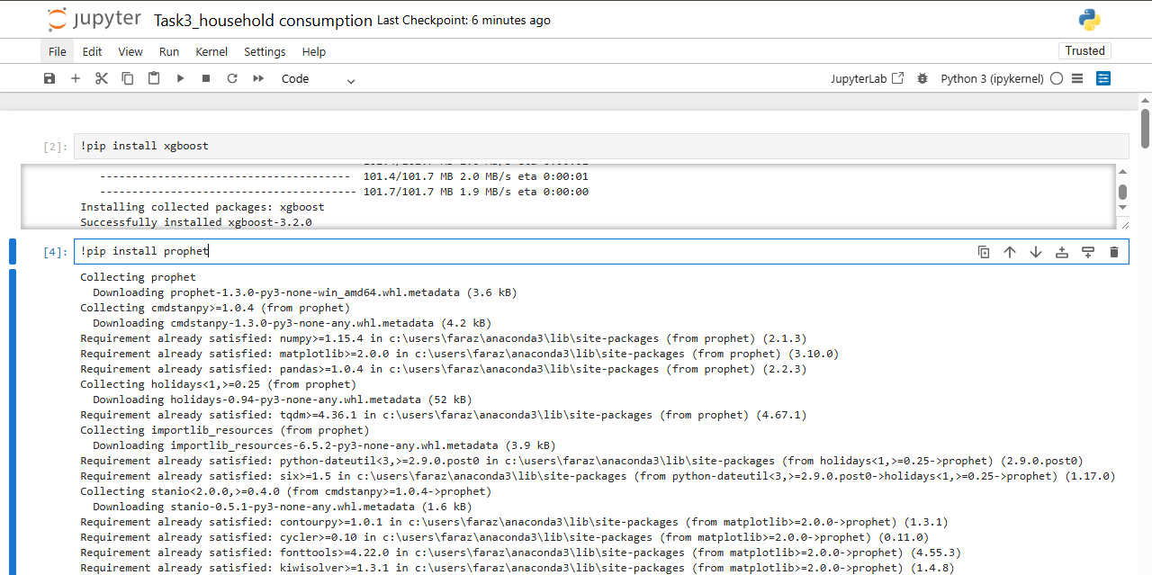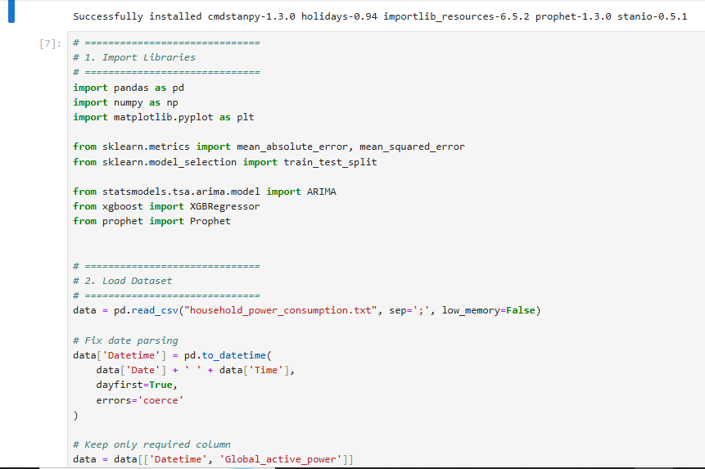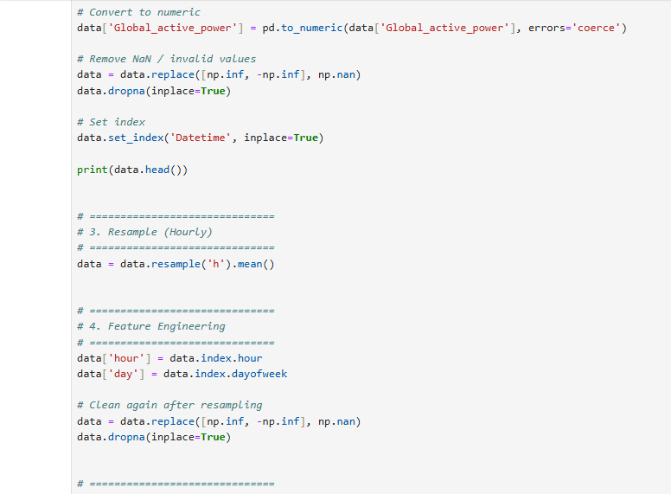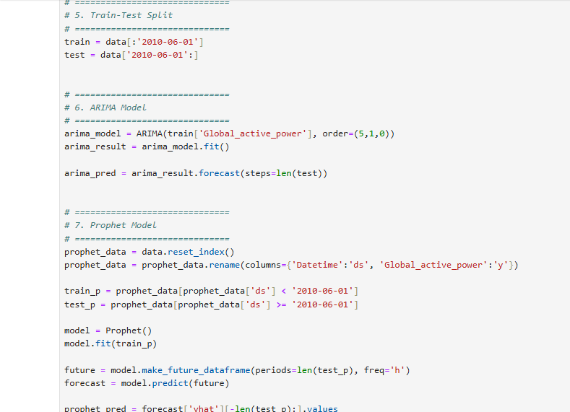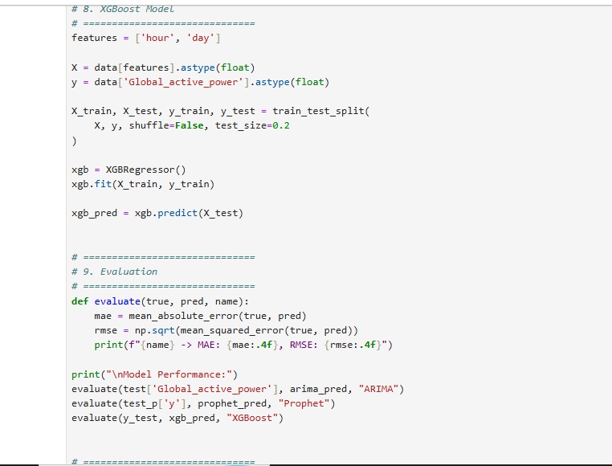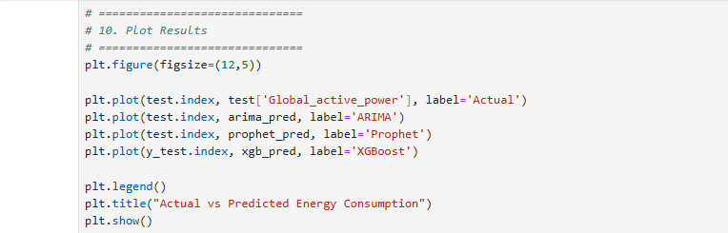

OUTPUT:
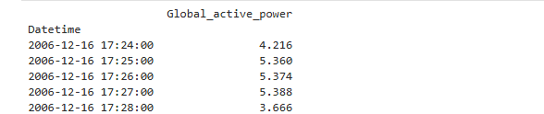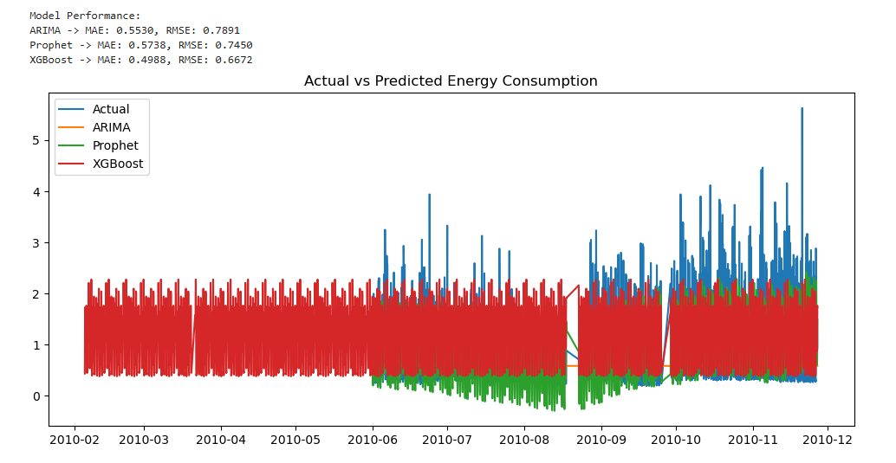

8. Results Comparison:
- ARIMA performed well for simple trend patterns
- Prophet handled seasonality effectively
- XGBoost gave strong performance for complex relationships
Overall, XGBoost/Prophet performed better than ARIMA in most cases.

9. Visualization:
A graph was plotted comparing:
- Actual energy consumption
- Predicted values from ARIMA, Prophet, and XGBoost
This helped in visually understanding model performance.

10. Business Insights:
From the analysis:
- Energy usage varies by time of day
- Peak consumption occurs during specific hours
- Predictive models can help in energy planning
- Utilities can reduce waste using forecasting models

11. Conclusion:
In this task, we successfully applied time series forecasting techniques to predict household energy consumption.
Multiple models were implemented and compared. XGBoost and Prophet performed better than ARIMA in capturing complex patterns.
This system can help in efficient energy management and forecasting demand.

12. Future Improvements:
- Use deep learning models like LSTM
- Improve feature engineering with weather data
- Optimize hyperparameters for better accuracy
- Handle seasonality more effectively

